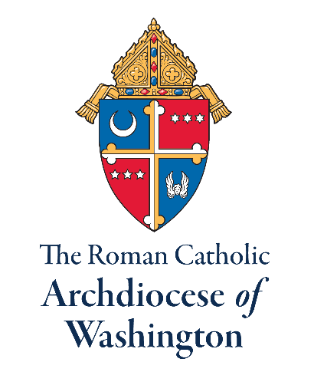

Position Summary
The mission of The Roman Catholic Archdiocese of Washington is to spread the light of the Gospel of Jesus Christ to the world. In the faithful pursuit of this mission, the archdiocese is seeking an Associate Director of the Office of Family Life.
The Associate Director of the Office of Family Life serves the needs of the clergy and parishioners in building, strengthening, and supporting a culture of marriage and family life for evangelization in the Archdiocese of Washington through collaboration with archdiocesan clergy, leaders and offices.

Duties and Responsibilities

- Recruit, develop and train teams of volunteers for parish family ministry.
- Support NFP (Natural Family Planning) introduction and training
- Manage database of parish family life ministry contacts
- Collaborate with other offices to promote and develop resources for NFP awareness week
- Assist with creating and delivering regular communications
- Update content management for our websites in collaboration with the Secretariat of Communications.
- Communicate initiatives of the Office of Family Life
- Coordinate marriage preparation and NFP planning classes
- Assist in the planning of Family Life Office annual events
- Provide training for marriage enrichment and chastity education
- Collaborate with other diocesan offices in the service of parishes

Knowledge, Skills, and Experience

- Practicing Catholic who supports the teachings of the Catholic Church
- Excellent oral and written skills
- Strong presentation skills
- Able to work evenings and weekends
- Spanish language skills
- Proficiency in Adobe Creative Suite
- Knowledge of social and digital media

Education and Training

- College degree
- Three to five years’ experience in parish ministry management/leadership

Please forward resume and cover letter to Lisa Calla-Russ calla-russl@adw.org

